**Project Document**

**Title**: Prevent User Deletion If Assigned To An Incident.

**1.Introduction**

In an IT Service Management environment, users are frequently assigned to incidents for issue resolution and tracking. However, the current system lacks a validation mechanism to prevent the deletion of a user who is still actively assigned to incidents. This can lead to broken data references, loss of accountability, and disruption in workflow continuity.  
There is a need to implement a safeguard that prevents such deletions unless all assigned incidents are closed or reassigned.

**1.1.User Creation**

Create Test Users:

Steps To Create Test Users.

1. Go To Servicenow ? All? Users (under system security)
2. Click on new
3. Create two users (e. g kiran123, ajaykumar)
4. Submit and verify user records.

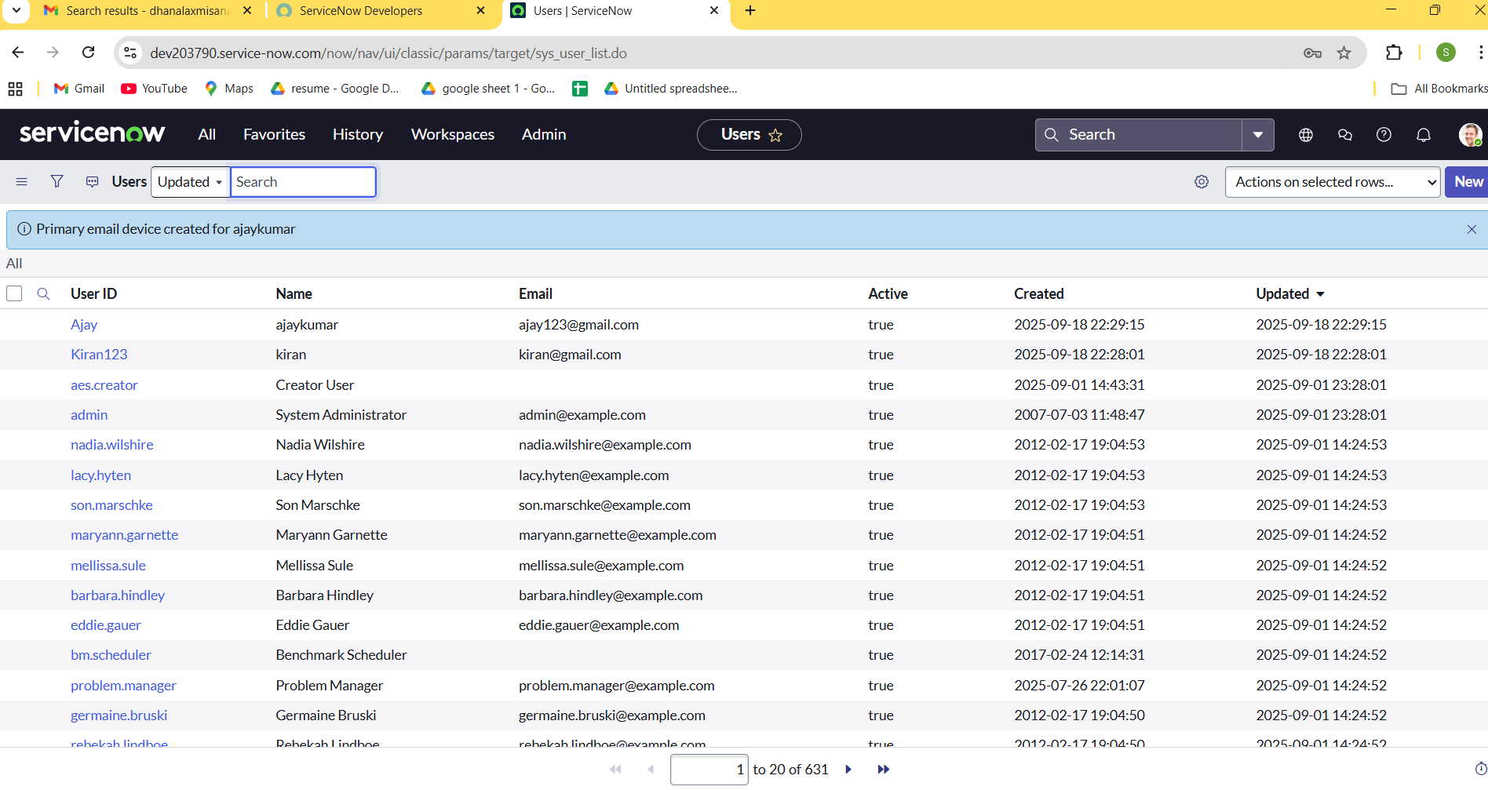

**1.2 Assigned Incident To User**

**Assign Incidents**

Steps To Assign Incidents To User

1. Navigate to the Incident table.
2. Create a new incident and assign it to one of the created users (e.g., kiran123)
3. Keep the incident Active = true and State = In Progress

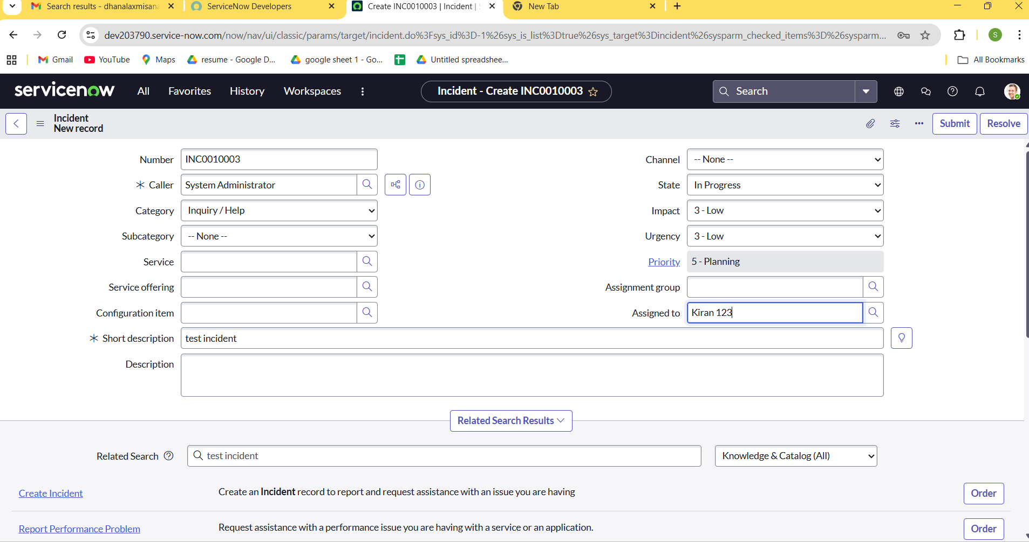

**Note:** To assign any user the user should have at least one role so assigned a role to the user  before assigning incident

**2.1 Business Rule Creation**

**Create Business Rule**

Steps to create business rules.

1. Go to System Definition ? Business Rules
2. Click on New
3. Fill in:
4. Name: Prevent User Deletion if Assigned to an Incident
5. Table: sys_user
6. When: Before
7. Delete: Checked
8. **Script:**

(function executeRule(current, previous /*null when async*/) {

var incGr = new GlideRecord('incident');

    incGr.addQuery('assigned_to', current.sys_id);

    incGr.setLimit(1); // Just need to check existence

    // incGr.addQuery('active', true); we can use  the above or this line of code to check where the user is assigned with any incident

    incGr.query();

    if (incGr.next()) {

        gs.addErrorMessage('This user cannot be deleted because they are assigned to one or more incidents.');

        current.setAbortAction(true);

    }

// Add your code here

})(current, previous);

1. Click Submit

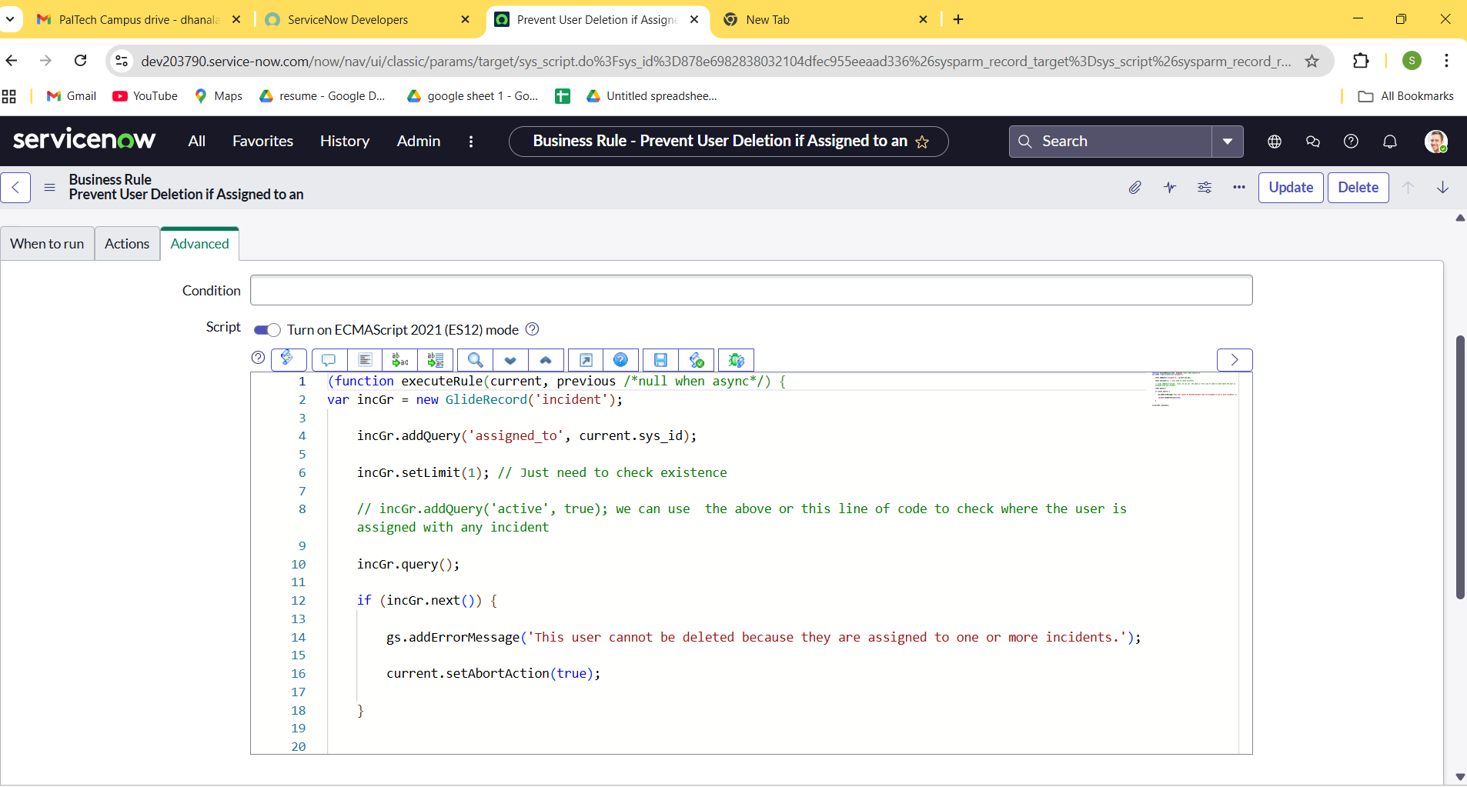

**2.2 Test Deletion**

**Attempt To Delete Assigned User**

1. Go to the user record (kiran123)
2. Click Delete
3. Verify that deletion is blocked with an error message

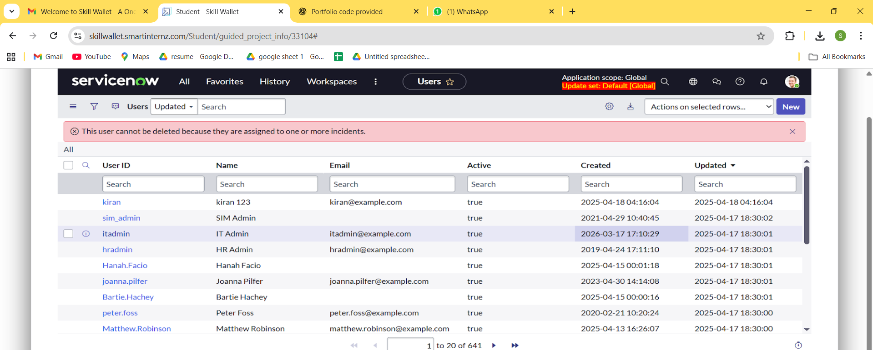

**3.1.Test With Unassigned User**

**Attempt To Delete Unused User**

1. Try deleting the second user (Ajaykumar) who is not assigned to any active incidents.
2. Deletion should succeed.

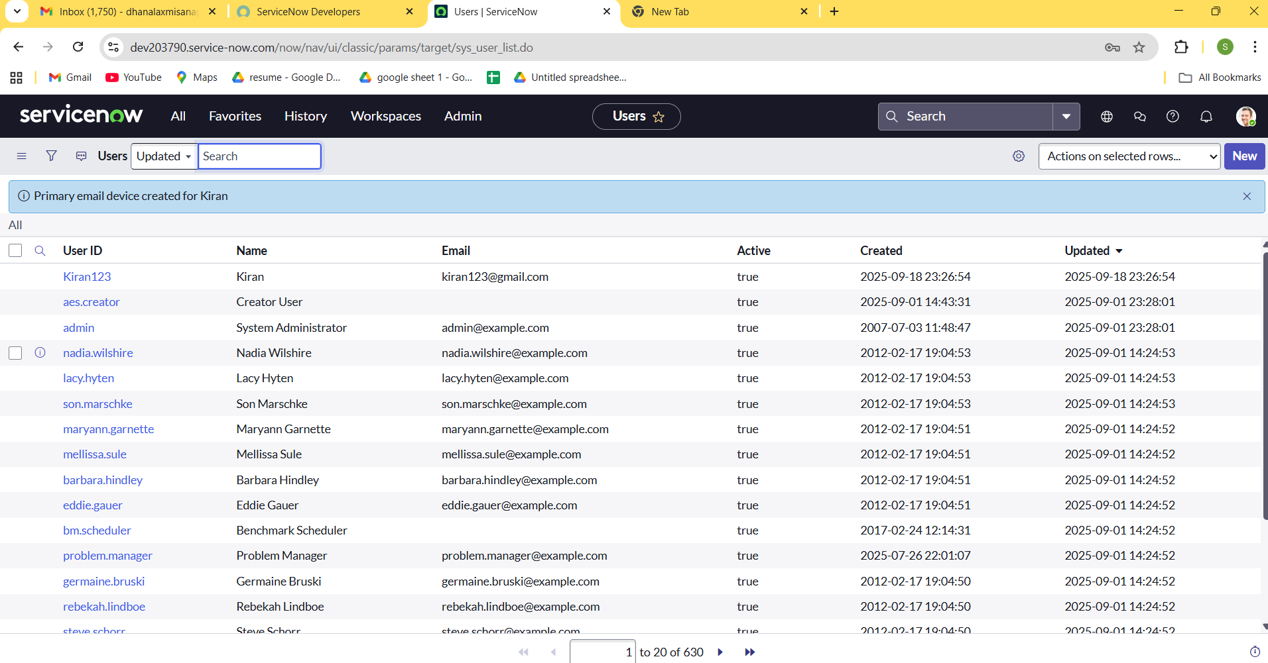

**4.Final Outcome:**

This project provides a safeguard mechanism against accidental or improper deletion of users who are still involved in active incidents. By using a Business Rule on the sys_user table, ServiceNow administrators can ensure that incident ownership and workflow integrity remain intact. This solution upholds data consistency and promotes operational continuity within IT service processes